Experiment No. 07

Name of the Experiment : Familiarization with Oscilloscope, Function Generator and with Alternating Current (AC) waves.
Objective:
This experiment is designed for the under-graduate students to introduce themselves and to be familiar with the oscilloscope and its operation. This experiment will help the students to have basic ideas about key functions of different knobs of oscilloscope and also to know how to measure voltage/current of a circuit-using oscilloscope as a measuring instrument.

Introduction:
Oscilloscope is probably the single most versatile and useful Test and Measurement instrument invented for Electronic measurement applications. It is a complex instrument capable of measuring or displaying a variety of signals. This is the basic equipment used in almost all electronic circuit design and testing applications. The major subsystems in an oscilloscope are Power supplies (high and low voltage supplies).
Display subsystem, Vertical and Horizontal amplifiers and display systems. There are two major types of oscilloscopes, viz. Cathode Ray Oscilloscopes (CRO) also called Analog Oscilloscopes, and Digital Storage Oscilloscopes (DSO), occasionally called Digital oscilloscopes. There are some analog oscilloscopes which also have the extra facility to store waveforms in digital form; these are called mixed-mode (i.e. Analog/Digital) oscilloscopes.
The main use of an oscilloscope is to obtain the visual display of an electrical voltage signal. If the signal to be displayed is not in the voltage form, it is first converted to this form. The signal voltage is then transmitted to the oscilloscope along a cable (usually a coaxial cable) and enters the oscilloscope where the cable is connected to the scope input terminals. Often the signal at this point is too small in amplitude to activate the scope display system. Therefore, it needs to be amplified.

1. Analog Oscilloscope: Cathode Ray Oscilloscope (CRO):

In a CRO the X and Y signals are applied to the horizontal and vertical plates, respectively of the cathode ray tube (CRT) after amplification. Within the CRT, an electron beam is created by an electron gun.
The electron beam is focused and directed to strike the fluorescent screen, creating as pot of light, where impact is made with the screen. The beam is deflected vertically in proportion to the amplitude of the voltage applied to the CRT vertical deflection plates. The amplified input signal is also monitored by the horizontal deflection system. This subsystem has the task of sweeping the electron beam horizontally across the screen at a uniform rate. A saw-tooth type signal (a triangular/ramp signal with long time duration for the rising part of the ramp and very small time duration for the falling part) is internally generated in a CRO as a time-base signal (sweep signal). This signal is amplified and applied to the horizontal deflection plates of the CRO. Again, the beam is deflected horizontally in proportion to the amplitude of the voltage applied to the CRT horizontal deflection plates.

The simultaneous deflection of the electron beam in the vertical direction (by the vertical deflection system and the vertical deflection plates) and in the horizontal direction (by the time-base circuitry and the horizontal deflection plates) causes the spot of light produced by the electron beam to trace a path across the CRT screen.

For example, if the input signal to the CRO were a sine wave, the trace produced on the CRT screen will be a sine wave. It is important to obtain a stable display on the CRT screen. If the input signal is periodic and the time base circuitry properly synchronizes the horizontal sweep with the vertical deflection, the spot of light will trace the same path on the screen over and over again.
For a periodic signal the input signal can be synchronized with the time-base signal using the
Trigger controls and the time base controls. If the frequency of the periodic signal is high enough (say greater than 40 Hz), the repeating trace will appear to be a steady pattern painted by solid lines of light on the screen.

Front view of the analog oscilloscope:
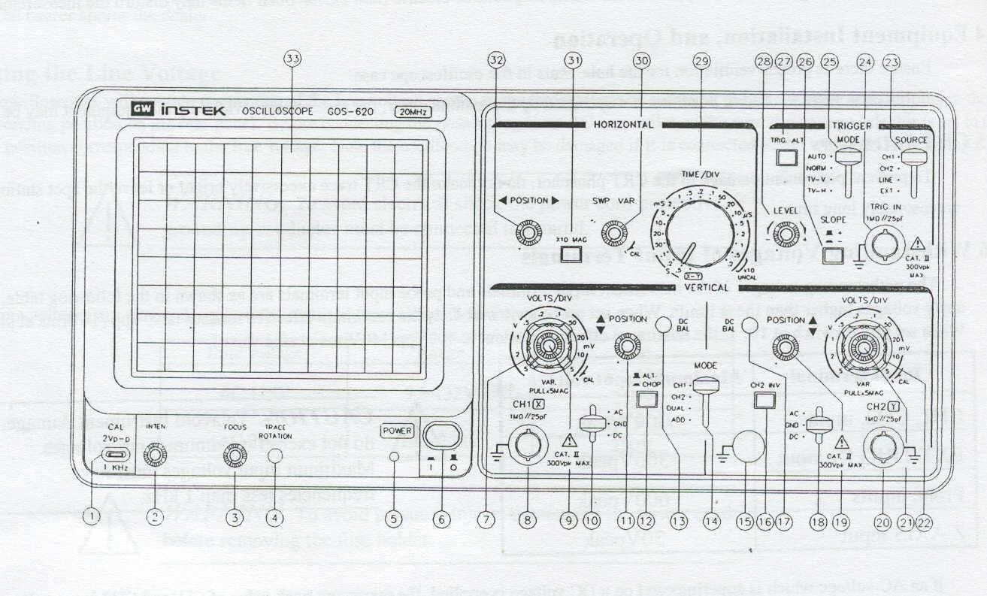

Introduction to front Panel:
The front panel consists of the following parts:
- CRT
- Vertical axis
- Triggering
- Time
- Others

Brief description:

1. CRT:
- Power (6)
The main power switch.
- Inten (2)
Controls the brightness of the spot.
- Focus (3)
For focusing the spot for sharp image.
- Trace rotation (4)
For aligning the horizontal trace in parallel with graticule lines. e) Filter
(33)

2. Vertical axis:
- CH1 (X) input (8)
Vertical input of CH1. When in X-Y mode this acts as an X-axis input
- CH2 (Y) input (20)
Vertical input of CH2. When in X-Y mode this acts as a Y-axis input
- AC-GND-DC (10,18)
Switch for selecting connection mode between input signal and vertical amplifier. d) Volt/Div (7,22)
Selection of vertical axis sensitivity, from 5mV/Div to 5V/Div in 10 ranges. e) Variable (9,21)
- CH1 & CH2 DC BAL (13,17)
- Position (11,19)
Control the position of the vertical trace or spot.
- Vert mode (14)
There are four positions to switch the operation of CH1 and CH2.When position in either CH1 or CH2; then oscilloscope operates as single channel instrument with CH1 or CH2 respectively. When position in DUAL then the oscilloscope operates as dual–channel of both CH1 and CH2. When position in ADD, then oscilloscope
displays the algebraic sum (CH1+CH2) or difference (CH1-CH2). During difference operation, CH2 INV must be pushed.
- ALT/CHOP (12)
When this switch is released then CH1 and CH2 are alternately displayed. When this switch is engaged then CH1 and CH2 are chopped and displayed simultaneously.
- CH2 INV (16)
This inverts the CH2 input signal when this knob is pushed in.

3. Triggering:
- EXT TRIG IN input terminal (24)
- SOURCE (23)
  - CH1: When Vert mode switch is at DUAL/ADD position select CH1 for internal triggering.
  - CH2: When Vert mode switch is at DUAL/ADD position select CH2 for internal triggering.
  - TRIG.ALT: It will alternately select CH1 and CH2 for internal triggering.

4) Line

5) EXT
- SLOPE (26)
  - ‘+’: Triggering occurs when triggering signal crosses triggering level in +ve going direction.
  - ‘—': Triggering occurs when triggering signal crosses triggering level in –ve going direction.
- LEVEL (28)
To display synchronized stationary waveform and set a start point of it.
- TRIGGER MODE (25)

4. Time Base:
- TIME/DIV (29)
Ranges are available from 0.2 μsec/div to 0.5 sec/div in 20 steps. X-Y mode: This position is used when oscilloscope functions as an X-Y oscilloscope.
- SWP.VAR (30)
- Position (32)
Control the position of the horizontal trace or spot.
- x 10 MAG (31)
When this button is pushed, magnification of 10 occurs.

5. Others:
a) CAL (1)
This terminal gives the calibration voltage of 2 Vp-p, 1 kHz, and positive square wave. b) GND (15)
The ground terminal of the oscilloscope mainframe.

Basic operation with oscilloscope:

1. Single channel operation:

- Set the AC-GND-DC of both channels in the GND position and align the trace with horizontal central line and then set to AC position.
- Adjust the FOCUS control so that the trace image appears sharply.
- Set the VOLTS/DIV switch at 1 V and TIME/DIV switch at 0.5 ms position so that signal waveform is displayed clearly.
- Adjust vertical POSITION and horizontal POSITION controls in appropriate position so that the displayed waveform is aligned with the graticule and voltage (p-p) and period (T) can be read conveniently.

2. Dual-channel operation:

Set the Vert mode switch to DUAL state so that both channels are displayed simultaneously.

3. Frequency measurement:

- The frequency of any waveform can be measured by adjusting the TIME/DIV control knob of oscilloscope. Adjust the TIME/DIV control knob to position 0.5 ms to observe the waveform.
- Now measure the frequency of the wave using the following formula:
1 large square or 5 small squares = t sec,
# of small squares required to represent a full cycle of wave =n sec Where, n may have fraction value.
Time period, T = (n/5) × t s
Frequency, f = 1/T Hz



t

T

16

small

squares

Function generator:
Another major equipment commonly in electronic circuit applications, is a Function Generator (FG).As the name indicates, a Function Generator generates different voltage signals, such as Sine, Pulse, and Triangle.
The most commonly required signals in electronic circuits are Sine and Pulse. Sine wave signals find their use mostly in Analog circuits, such as amplifiers, filters, etc. Pulse signals are useful in testing the time response of circuits and also as Clock signals in Digital circuits. In a general pulse signal, the high and low level time periods are different. Square wave is a special case when the periods are equal.
In a FG by the touch of a button one can choose a variety of signals. This is possible because of the fact that one can obtain different signals from a starting signal using wave shaping circuits. The synthesized function generators, the waveforms are generated by digitally stored signals through digital to analog converters.
In the lab you will be using the Model SFG2110 Synthesized Function Generator (by M/s GW Instek, Taiwan) which is a 10 MHz function generator.
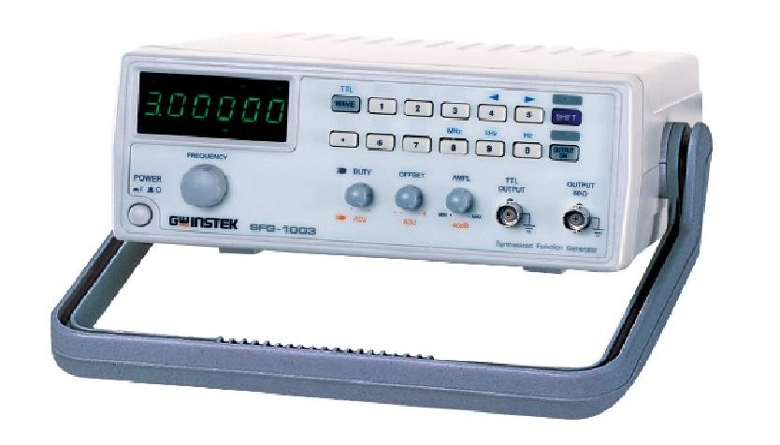
Fig: Function Generator

Basic operation with function generator:
- Power on the generator and select the desired output signal: square wave, sine wave or triangle wave.
- Connect the output leads to an oscilloscope to visualize the output signal and set its parameters using the amplitude and frequency controls.
- Attach the output leads of the function generator to the input of the circuit you wish to test.
- Attach the output of your circuit to a meter or oscilloscope to visualize the resulting change in signal.

Digital storage oscilloscope (DSO):
- A DSO samples the input waveform and uses an analog-to-digital converter (or ADC) to convert the voltage being measured into digital information. It then uses this digital information to reconstruct the waveform on the screen.

- The ADC in the acquisition system samples the signal at discrete points in time and converts the signal's voltage at these points to digital values called sample points.
- The horizontal system's sample clock determines how often the ADC takes a sample.
- The rate at which the clock "ticks" is called the sample rate and is measured in samples per second. The sample points from the ADC are stored in memory as waveform points.
- More than one sample point may make up one waveform point. • Together, the waveform points make up one waveform record.
- The number of waveform points used to make a waveform record is called the record length. • The trigger system determines the start and stop points of the record.
- The display receives these record points after being stored in memory. Depending on the capabilities of the oscilloscope, additional processing of the sample points may take place, enhancing the display. Pre-trigger may be available, allowing you to see events before the trigger point.
- Fundamentally, with a digital oscilloscope as with an analog oscilloscope, you need to adjust the vertical, horizontal, and trigger settings to take a measurement.

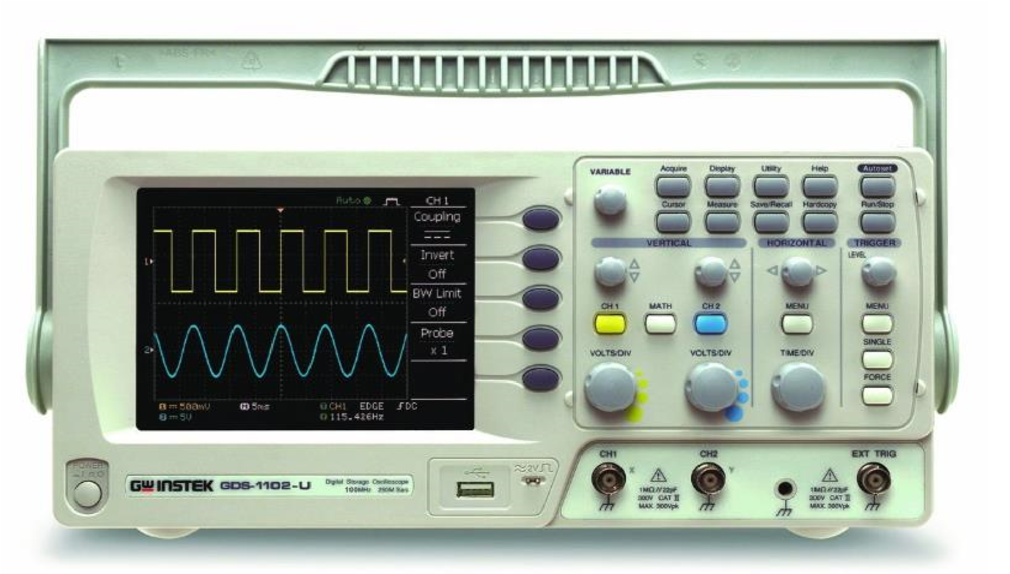
Fig: Digital Storage Oscilloscope

Brief description:
A schematic diagram of the DSO front panel is shown above. Other than the LCD display, There are five major sections on the front panel of the DSO:
Section 1 – The five function keys located on the side of the display.
Section 2 – the section below the display consisting of Power switch, and probe compensation output (calibrated source).
Section 3 – A variable knob and Ten Menu keys located on the top side to the left of the display. Section 4 – Knobs and buttons located in three columns at the center part, indicated as: VERTICAL,
HORIZONTAL, and TRIGGER.
Section 5 – Located at the bottom part to the left of the display are input BNC sockets for CH-1, CH-2 and External Trigger terminals, and an extra socket for GND.
DSO operations require the use of a combination knobs and buttons. You need to familiarize yourself well with all the basic operations in order to perform experiments and make measurements using the DSO in the lab. Basic operations of the DSO:

a) Channels CH-1 and CH-2:
The signal display part of the LCD screen is 10cm (X-axis) long and 8cm (Y-axis) high. For convenience channels are indicated with different colors. Signal connected to Channel 1 (CH-1) would appear YELLOW on the LCD screen.
Numera1-1 is also indicated on the extreme left side of the display. CH-1 controls are also given yellow color. By pressing the yellow button (CH 1), this channel (and display) can be turned on or off. The Volts/Div. knob indicates the Y-scale in volts/full div or volts/cm. Signal to CH-1 should be connected to the BNC connector seen just below the Volts/div knob.
Similarly, the signal to CH-2 should be connected to the socket below the CH-2 Volts/div knob. CH-2 display would appear blue on the LCD screen. Numeral-2 is also indicated. Note that the DSO can display signals simultaneously on two channels.

b) CH-1 and CH-2 Coupling Modes:
Press the required channel button (CH-1 or CH-2). Now sub-menu for that channel would appear at the left side of the screen.
Choose the top option, “Coupling” by pressing the first function key. The current coupling mode would be displayed below the line “Coupling”.
The three possible coupling modes are DC (two lines: solid line and broken line), AC (sine wave), and GROUND (ground sign).

As you press this function key the coupling modes keep changing. The present mode would be displayed below the “Coupling” function.
The most common coupling mode is DC, which would enable you to measure both dc and ac levels of the signal.
In the AC mode, the dc content of the signal would be removed. GROUND mode is used to choose the reference zero level for the Y-axis. In this mode DSO disconnects the input signal and connects the channel to ground.

c) Triggering the display:
Proper triggering of the signal is required to get a stable display. When the signal is properly triggered, a message in green color “Trig’ d” would appear on the top. By pressing the “MENU” button in the “TRIGGER” column (extreme right column), various options for triggering are
obtained. These are Type: Edge, Pulse, and Video Source: CH 1, CH 2, External, Line .
Slope/Coupling: Slope (+ve/ –ve), Coupling (DC/AC), Rejection (Off/LF/HF), Noise Rej(Off/On)
Mode: Auto
For normal use choose Type: Edge, Source: CH1 or CH2, Slope (+ve or –ve), Coupling: DC

d ) Horizontal Functions:
There are three controls under HORIZONTAL (middle column). Top one is the horizontal position knob used to move the display in the X-direction. Bottom one is the “TIME/DIV” knob used to select the time base scale (X-scale). This can range from 10sec/div to 1ns/div. The current time base scale setting will be displayed at the bottom, a little left to the center line. A proper setting of the channel Volts/div and Time/div are required to get a clear display. The middle button “MENU” in this column is used to choose the Display mode.

e ) Display Modes: Main and XY Modes:
Press the “MENU” button, located just above the TIME/DIV knob located among the Horizontal controls (middle column). For normal operations, where you want to display the input signal continuously, the mode should be “Main”. To get the XY mode, press the XY function key in this menu. XY mode is occasionally used to get the XY plot of the two signals connected to CH-1 and CH-2. In the XY mode, CH-1 signal is taken as the X-axis input and CH-2 the Y-axis.

f ) AUTOSET Function:
This button may be thought of as the ‘panic’ button. This button may be pressed when you think that you are lost and needs help (with regard to displaying the signals on the DSO properly!). Once the AUTOSET button is pressed (extreme top right button) the DSO measures the amplitudes and time periods of the input signals connected to CH-1 and CH-2 and automatically chooses the correct Volts/Div, Time/Div, and Trigger mode settings.

g) Function key:
These key are used to measure various quantity of an electrical signal which is varied by variable knob.

Note:
- Don’t put any sort of electrical equipment’s (such as signal generator, dc supply etc.) on the top of the oscilloscope.
- Place the oscilloscope away from any magnetic field (as far as possible)
- If the GND horizontal line deviates significant amount then adjust it by rotating the position of oscilloscope.
- Always check the 10x switch of probe according to your measurement.
- Always avoid common grounding resulting from improper connection of knobs in the circuit.

Results and Discussion:
Interpret the data /findings and determine the extent to which the experiment was successful in complying with the goal that was initially set.
Detect the variation between theory and experimental result if any and propose the ways /procedures to overcome the variations.
State the particular steps adopted to overcome the deviations between theory and experiment.

Conclusion:
Summarize the experiment and discuss whether the objective were fulfilled or not within a short paragraph.

Viva Sample Questions:
- Define current?
- Define voltage?
- Define Peak Voltage?
- Define Peak to Peak Voltage?
- Define Frequency?
- What do you mean by Oscilloscope Calibration?
- Explain the way of measuring Peak voltage?
- Explain the way of measuring frequency?

Experiment No. 08

Experiment Name: Investigation & measurement of phase shift and reactance in RC and RL circuit.

Introduction:
A resistor-Inductor circuit is defined as an electrical circuit consisting of the passive circuit elements of a resistor (R) and an inductor (L) connected, in series, driven by a voltage source. A resistor Capacitor circuit is defined as an electrical circuit consisting of the passive circuit elements of a resistor (R) and a capacitor (C) connected, in series, driven by a voltage source.

Objectives:
The experiment aims to study the electrical characteristics of an RL and RC circuit in series. Also, to study the relation between the input frequency f and the circuit impedance X_{L}, X_{C} Components:
- Function generator. • Oscilloscope.
- Digital Multimeter.
- Resistor.
- Connection wires. • Inductor.
- Capacitor

Theory:
Consider a simple RL circuit in which resistor, R and inductor, L are connected in series with a voltage supply of V_{in}. The current flowing in the circuit is I and the current through resistor R and inductor L is IR and IL respectively. However, the resistor and inductor are connected in series, that’s why the current passing through both elements is the same. i.e.,
𝐼_{𝑅} = 𝐼_{𝐿} = (1)
The voltages V_{R} and V_{L} are the voltage drop across the resistor and inductor.
By applying the Kirchhoff voltage law (The summation of the drop voltages across R and L equal to the input voltage V_{in}) to this circuit, we get:
𝑉_{𝑖𝑛} = 𝑉_{𝑅} + 𝑉_{𝐿} (2)
Before drawing the phasor diagram of a series RL circuit, one should know the relationship between voltage and current in the case of resistor and inductor.
In the case of the resistor R, the voltage and current are in the same phase, or we can say that the phase angle difference between voltage and current is zero.
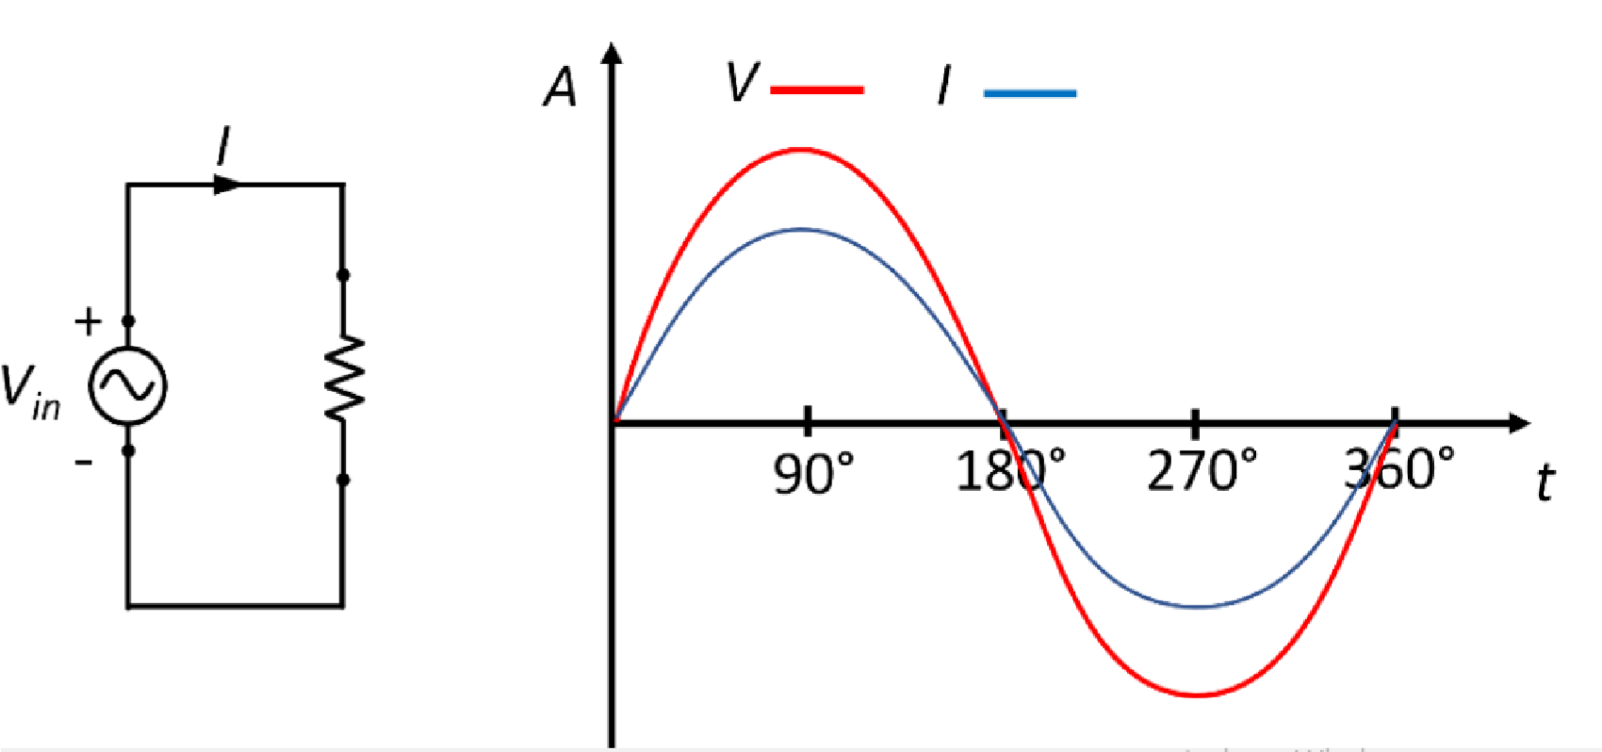

Figure 1: illustrate that the voltage and current wave are in phase in purely resistive load
Inductor (also named as a choke) is basically a coil or loops of wire that are either wound around a hollow tube former (air cored) or wound around some ferromagnetic material like iron core to increase their inductive value (inductance).
In the case of the inductor L, the voltage and current are not in phase. The voltage leads the current by 90°. This means the voltage reaches its maximum when the current attains the zero value.
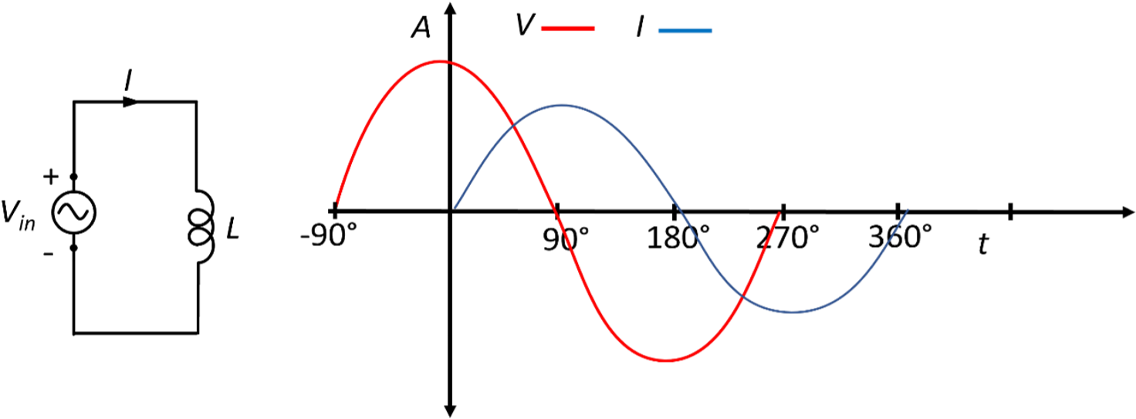
Figure 2: illustrate the voltage and current phase shift in a purely inductive load
The actual opposition to the current flowing through a coil in an AC circuit is determined by the AC Resistance of the coil with this AC resistance being represented by a complex number. But to distinguish a DC resistance value from an AC resistance value, which is also known as Impedance, the term Reactance is used.
Like resistance, reactance is measured in Ohm’s but is given the symbol X to distinguish it from a purely resistive “R” value and as the component in question is an inductor, the reactance of an inductor is called Inductive Reactance, X_{L} and is measured in Ohms. Its value can be found from the formula.
𝑋_{𝐿} = 2𝜋𝑓𝐿 (3)
Where X_{L} is inductive reactance in (Ω), π is the numeric constant of 3.142, ƒ is the frequency in Hz, and L = inductance in H
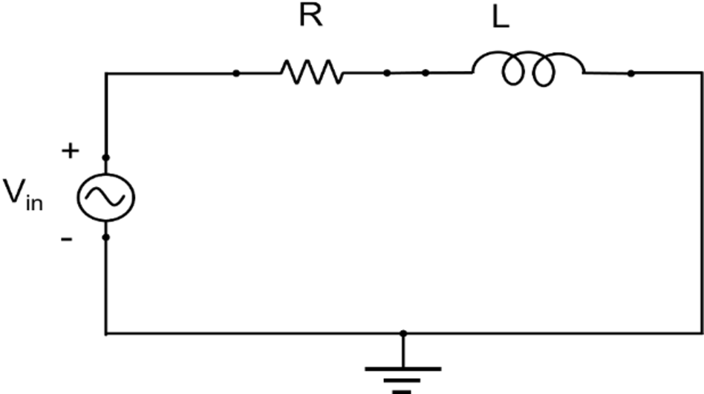

+
V
R

-

+
VL
-

Figure 3: Schematic diagram illustrate an RL circuit connected in sereis

This simple circuit above consists of a pure inductance of L Henries (H), connected in series with a resistor R (Ohm) and a sinusoidal voltage given by the expression:
V_{in} = V_{max} sin ωt (4)
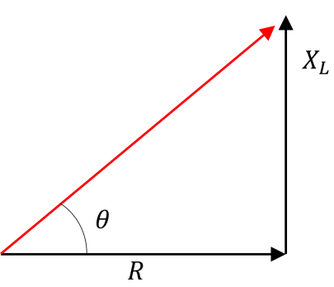
Figure 4: For an RL circuit, depend on the values of the R and X_{L}.
In an RL circuit, a phase shift occurs as well between the voltage across the inductor V_{L} and the current I. As the circuit is a resistive-inductive load, the voltage V leads the current I, as shown in Fig. 4. The phase shift can also be calculated using equation 5
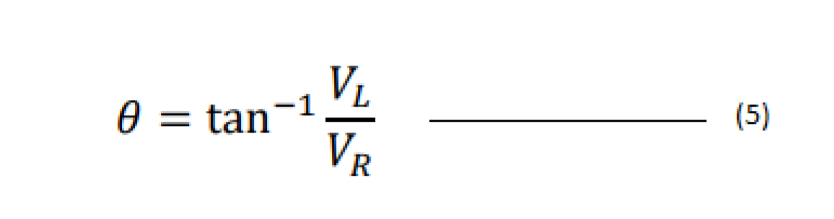

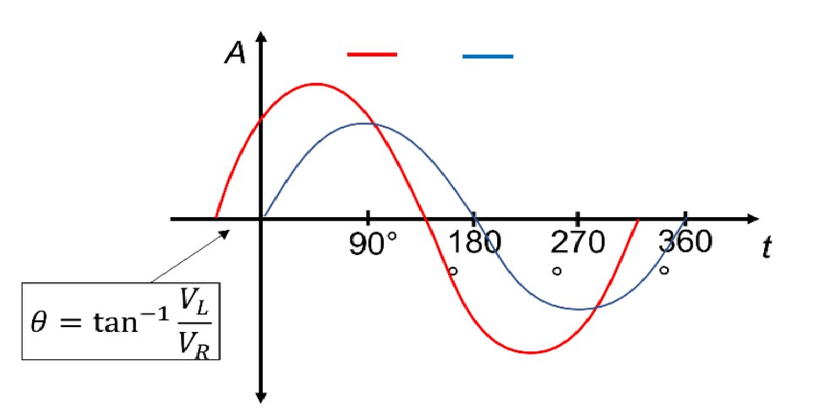
Figure 5: illustrate the voltage and current phase shift of a resistive
-
inductive
V
L

V
R

load.

Capacitor: A capacitor is a device that stores electrical energy in an electric field by virtue of accumulating electric charges on two close surfaces insulated from each other. It is a passive electronic component with two terminals.
The effect of a capacitor is known as capacitance. While some capacitance exists between any two electrical conductors in proximity in a circuit, a capacitor is a component designed to add capacitance to a circuit.
The reactance of a capacitor is called Capacitive Reactance, X_{C} and is measured in Ohms. Its value can be found from the formula.
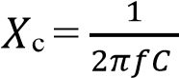 ………………………………. (6)
Where X_{C} is capacitive reactance in (Ω), π is the numeric constant of 3.142, ƒ is the frequency in Hz, and C = capacitance in µF

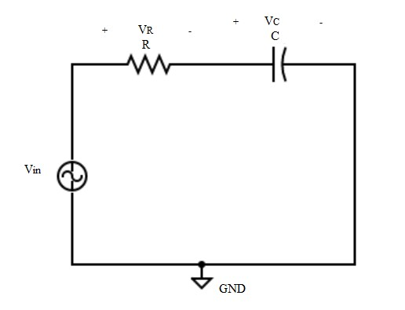

Figure 6: Schematic diagram illustrate an
RC

circuit connected in
series

+

-

This simple circuit above consists of a pure capacitance of C Farads (F), connected in series with a resistor R (Ohm) and a sinusoidal voltage given by the expression:
V_{in} = V_{max} sin ωt

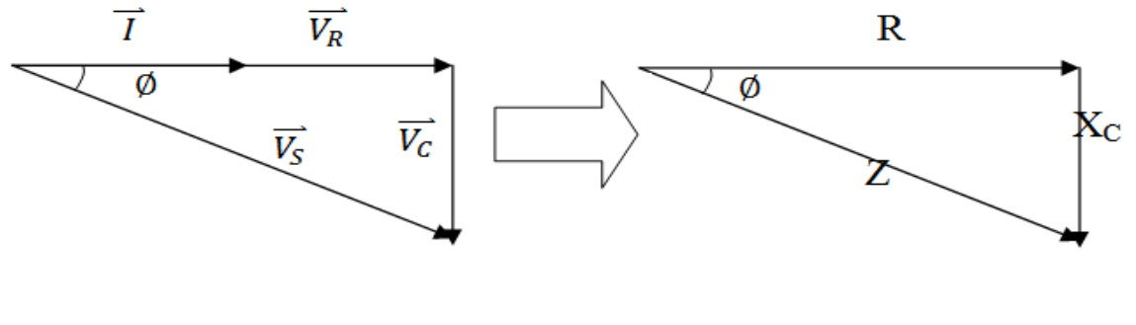
Figure 7: For an RC circuit, depend on the values of the R and X_{c}.
In an RC circuit, a phase shift occurs as well between the voltage across the inductor V_{c} and the current I. As the circuit is a resistive-capacitive load, the voltage V lags the current I, as shown in Fig. 7. The phase shift can also be calculated using equation 6,
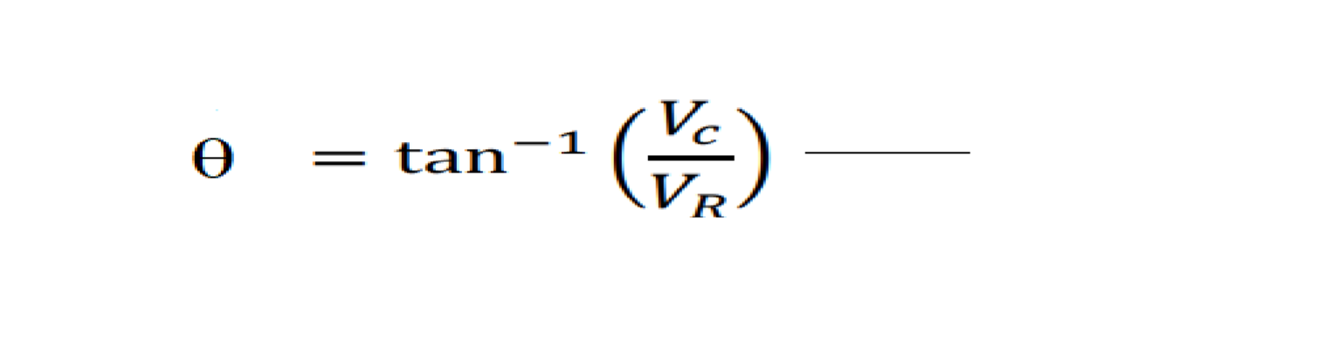

(7)

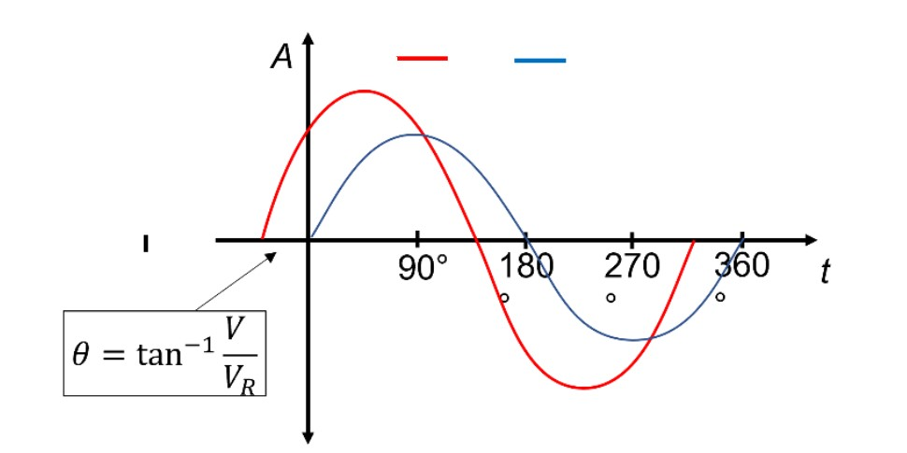

V
C

V
R

C

Figure 8: illustrate the voltage and current phase shift of a resistive-capacitive load.
Table 1, shows important equations required to theoretically calculate V_{R}, V_{L}, V_{s}, R, X_{L}, V_{c} and Z.
For voltages | For impedance
| | = |𝑉_{𝑆}| × cos() | = || × cos()
|𝑉_{𝐿}| = |𝑉_{𝑆}| × sin() | |𝑋_{𝐿}| = || × sin()
| | = √|𝑉_{𝑅}|² + |𝑉_{𝐿}|² | | | = √² + |𝑋_{𝐿}|²
|_{c}| = |𝑉_{𝑆}| × sin() | |_{c}| = || × sin()
| | = √|𝑉_{𝑅}|² + |_{c}|² | || = √² + |_{c}|²

Experiment procedure:
- Build the circuit shown in Fig. 3 using a 100Ω resistor and a 10 mH inductor.
- Set the input voltage at 10V (peak-peak) and frequency at 500 Hz.
- Using the Oscilloscope, find out phase shift.
- Change the input frequency from 500 to 1 kHz, 1.5 kHz, 2 kHz, 2.5 kHz, 3 kHz, 4 KHz and 5 KHz, find out phase shift.
- Follow step-2, Again, Using the Oscilloscope, read the voltage across the 100Ω resistor and the 10 mH inductor.
- Change the input frequency from 500 to 1 kHz, 1.5 kHz, 2 kHz, 2.5 kHz, 3 kHz, 4 KHz and 5 KHz.
- Measuring the voltage across the 100Ω resistor and the 10 mH inductor repeatedly.
- Based on the experimental measurement, calculate the phase shift () between V_{R} and V_{L} theoretically using equation 5.
- To find out X_{L}, use X_{L}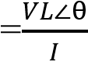[Note. I=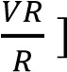
- Build the circuit shown in Fig. 6 using a 100Ω resistor and a 47 µF capacitor.
- Follow step-2 and find out phase shift using oscilloscope.
- Change the input frequency from 500 to 1 kHz, 1.5 kHz, 2 kHz, 2.5 kHz, 3 kHz, 4 KHz and 5 KHz, find out phase shift.
- Using the Oscilloscope, read the voltage across the 100Ω resistor and the 47 µF capacitor.
- Based on the experimental measurement, calculate the phase shift () between V_{R} and V_{C} theoretically using equation 7.
- Change the input frequency from 500 to 1 kHz, 1.5 kHz, 2 kHz, 2.5 kHz, 3 kHz, 4 KHz and 5 KHz.
- Repeat step 14, measuring the voltage across the 1kΩ resistor and the
4.7 µF capacitor.
- To find out X_{C}, use X_{C}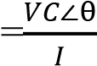[Note. I=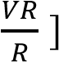
- Write down all the measured and calculated values.

Data Table:
No. of observation | Supply  Voltage  V(Peak) | Frequency  Hz | V_{R} V | V_{L} V | V  C  V | Phase  Shift, θ˚  From oscillosco  -pe | Phase  Shift, θ  ˚  From equatio  -n | Theoriti  -cally  X_{L}  Ω | Theor i-  tically  X_{C}  Ω | Experi  -mentally  X_{L}  Ω | Exper i-me-  ntally  X_{R}  Ω | Deviation of theoretically and  experimenta  -lly X_{L} and  XC (Ω)

Results and Discussion: Interpret the data /findings and determine the extent to which the experiment was successful in complying with the goal that was initially set.
Detect the variation between theory and experimental result if any and propose the ways /procedures to overcome the variations.

Conclusion:
Summarize the experiment and discuss whether the objective was fulfilled or not within a short paragraph.

Lab Viva Sample Questions:

- What is the relationship between inductive reactance and frequency?
- What is the relationship between inductive reactance and inductance?
- What is the relationship between capacitive reactance and frequency?
- What is the relationship between capacitive reactance and capacitance?

Experiment No. 09
Name of the Experiment: Verification of KVL and KCL in AC Circuit.

Objective: The objective of this experiment is to study series and series-parallel circuits when energized by an AC source and to construct their phasor diagram. KVL and KCL in phasor form will also be verified.

THEORY:
Kirchhoff's Voltage Law (KVL) states that in any closed loop in a circuit, the algebraic sum of the voltages across all the elements must be equal to zero. This law is based on the conservation of energy principle, which states that energy cannot be created or destroyed, only transferred or transformed from one form to another.

KVL is an important tool for analyzing circuits, particularly in the design and troubleshooting of electrical and electronic systems. It allows engineers and technicians to calculate the voltage drops across individual components in a circuit, and to identify any errors or problems that may be causing the system to malfunction.

In summary, KVL is a fundamental principle of circuit analysis that helps to ensure the proper functioning and reliability of electrical and electronic devices.
Applying Kirchhoff’s Voltage Law around closed loop of Figure 9.1 and Figure 9.2, we find,
V_{S}= V_{R} + V_{L} and V_{S}= V_{R} + V_{C}
Kirchhoff's Current Law (KCL) states that the algebraic sum of the currents entering and leaving any node in a circuit must be equal to zero. In other words, the sum of the currents flowing into a node must equal the sum of the currents flowing out of the node.

KCL is based on the principle of conservation of charge, which states that charge cannot be created or destroyed, only transferred from one point to another. This law is important for analyzing complex circuits with multiple branches, as it allows engineers and technicians to calculate the currents flowing through individual components and to identify any errors or problems that may be affecting the performance of the system.

In summary, KCL is a fundamental principle of circuit analysis that helps to ensure the proper functioning and reliability of electrical and electronic devices.
For the network of Figure 9.3 the currents are related by the following expression:

I = I₁ + I ₂

Required Equipment and Devices:
- Function Generator
- Oscilloscope
- Breadboard
- Resistor ( 1 KΩ )
- Capacitor (4.7 µF )
- Inductor (100 mH)
- Connecting Wire

Circuit Diagrams:
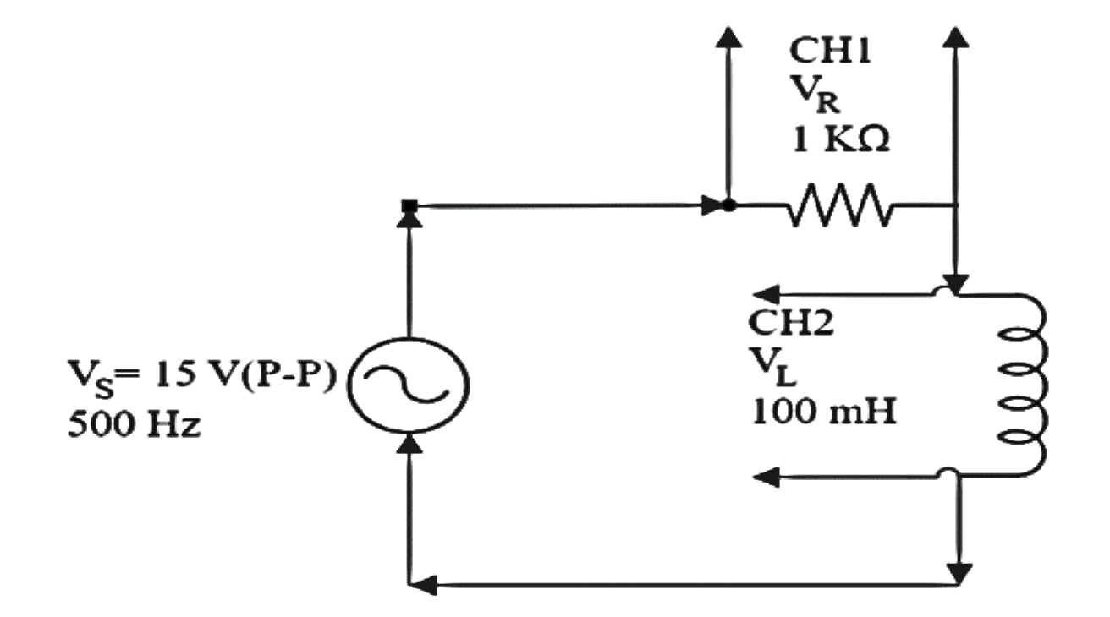
Fig 9.1

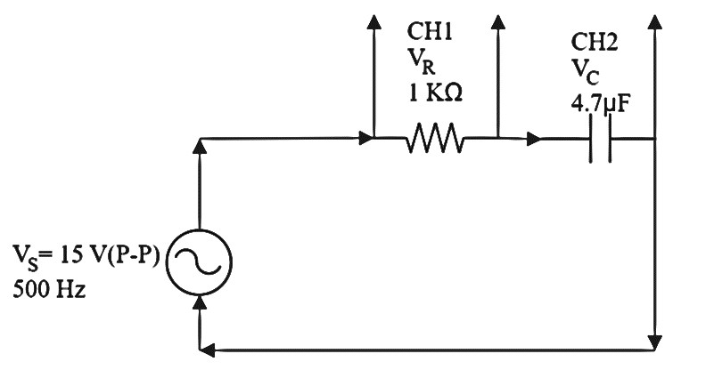
Fig 9.2

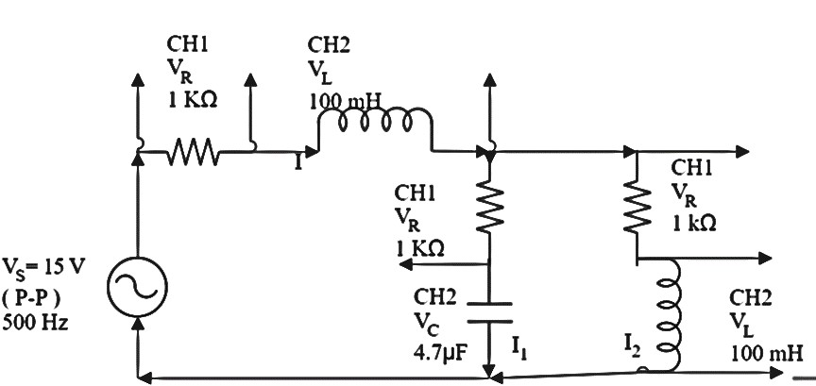
Fig 9.3

Experimental Procedure:

To Verify KVL
- Construct the circuit as shown in Fig. 9.1. Set the function generator to supply a voltage of 15 V (P-P) at a frequency of 500Hz.
- Measure V_{R} (CH1), V_{L} (CH2) (Peak to Peak) voltage and phase angle by Oscilloscope.
- Again, construct the circuit as shown in Fig. 9.2. Set the function generator to supply a voltage of 15 V (P-P) at a frequency of 500Hz.
- Measure V_{R} (CH1), V_{C} (CH2) (Peak to Peak) voltage and phase angle by Oscilloscope.

KVL (For Fig. 9.1) Data table:
VS  V | VR  V | VL  V |  | VR+ VL  V | Deviation  V

Calculation:

Suppose, V_{S}= 15 V, V_{R}= 14 V, V_{L}=5 V, Ɵ = 90˚
V_{S}= V_{R} + V_{L}∠Ɵ
15= 14 + 5∠90˚ [ putting values]
15= 14 + j5 [From polar to rectangular 5∠90˚ = j5]
15 ≈ 14.88∠18˚ [From rectangular to polar]

KVL (For Fig. 9.2) Data table:

VS  V | VR  V | VC  V |  | VR+ VC  V | Deviation  V

Calculation:

Suppose, V_{S}= 15 V, V_{R}= 14 V, V_{C}=5 V, Ɵ = 90˚
V_{S}= V_{R} + V_{C}∠Ɵ
15= 14 + 5∠90˚ [ putting values]
15= 14 + j5 [From polar to rectangular 5∠90˚ = j5]
15 ≈ 14.88∠18˚ [From rectangular to polar]

To Verify KCL
- Construct the circuit as shown in Fig. 9.3. Set the function generator to supply a voltage of 15 V (P-P) at a frequency of 500Hz.
- Measure V_{R} (CH1), V_{L} (CH2) (Peak to Peak) voltage and phase angle by Oscilloscope, [Note. R= 1Ω or 1kΩ, I=V_{R}/R, resistor and inductor are connected in series so same current will follow both of them.]
- End of step 5 & 6, we can get total current I with phase angle Ɵ.
- Now, in parallel side, Measure V_{R} (CH1), V_{L} (CH2) (Peak to Peak) voltage and phase angle by Oscilloscope.
- Current, I₂=V_{R}/R, resistor and inductor are connected in series so same current will follow both of them.
- End of step 8 & 9, we can get total current I₂ with phase angle
- Again, in parallel side, Measure V_{R} (CH1), V_{C} (CH2) (Peak to Peak) voltage and phase angle by Oscilloscope.
- Current, I₁=V_{R}/R, resistor and inductor are connected in series so same current will follow both of them.
- End of step 11 & 12, we can get total current I₂ with phase angle .
KCL (For Fig. 9.3)
Data table:
I (mA) |  |  | I₁(mA) |  |  | I₂(mA)
VR  V | VL  V |  | VR  V | VC  V |  | VR  V | VL  V

Calculation:

I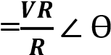, I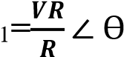, I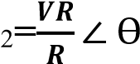, I= I₁+ I₂

To find out I,  Suppose, VR=10 V, R= 1Ω,  Ɵ = 90˚ | To find out I₁,  Suppose, VR=5 V, R= 1Ω,  Ɵ = 90˚ | To find out I₂,  Suppose, VR=5 V, R= 1Ω,  Ɵ = 90˚
I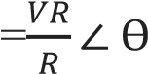, I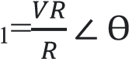, I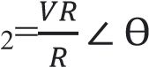,
I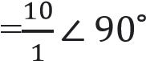, I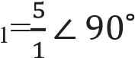, I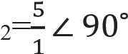,
I=10∠ 90˚ I₁=5∠ 90˚ I₂=5∠ 90˚

I= I₁+ I₂
10∠ 90˚ = 5∠ 90˚+ 5∠ 90˚ [putting values]
10∠ 90˚= j5 + j5 [From polar to rectangular 5∠90˚ = j5]
10∠ 90˚ = 𝑗10
10∠ 90˚ = 10∠ 90˚ [From rectangular to polar]

Results and Discussion:
Interpret the data /findings and determine the extent to which the experiment was successful in complying with the goal that was initially set.
Detect the variation between theory and experimental result if any and propose the ways /procedures to overcome the variations.
State the particular steps adopted to overcome the deviations between theory and experiment.

Conclusion:
Summarize the experiment and discuss whether the objective were fulfilled or not within a short paragraph.

Lab Viva Sample Questions:

- Define current.
- Define voltage.
- Define resistance.
- Define ohm’s law.
- State KVL. 6. State KCL.

